**Prepared By-**

Ishtiaque Hossain Sajid 1731485030

Md Aman Ullah 1610688030

MD. Badrul Hasan Riyad 1731292030

Rakib Mohammed Taher 1711835030

**Faculty-**

M Ashique Rahman

Senior Lecturer,

Department of Political Science & Sociology

North South University

HIS103: Emergence of Bangladesh

Section: 25

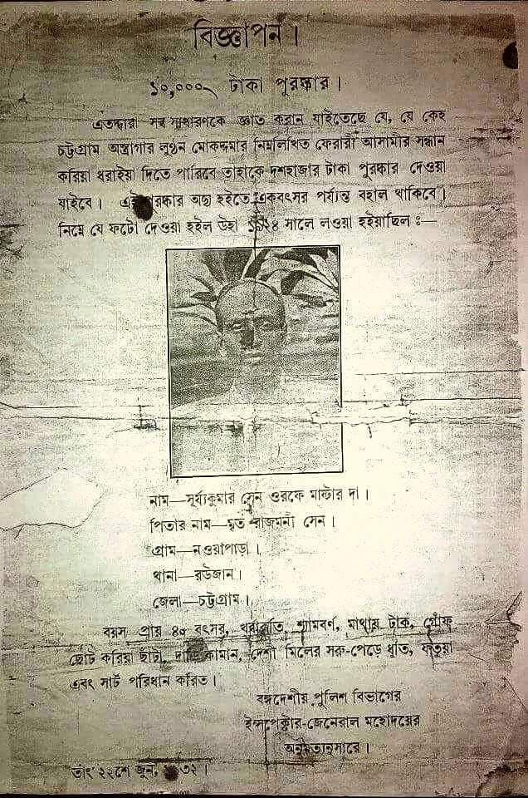

Chittagong Uprising: Chittagong Armory Raid and its impact on Indian Sub-Continent

Table of Contents

Introduction 2

Background History 3

Identity of the Raiders 5

Chittagong Armory Raid Plan 11

Execution of The Plan 12

Aftermath 20

Impacts of the Uprising: 23

Conclusion 24

Works Cited 25

# Introduction

Today’s India, Bangladesh, Pakistan were colonized under British for more than 200 years. Indian subcontinent became a crown colony in 1876. But the initial colonization process can be traced back to 1608, when started arriving in India for business purposes. Initially, the British contact with India was a result of fierce competition with Dutch and Portuguese for trading interest in Asia. Comparing to other Colonial power, British were a little bit latecomer in colonization process of India. The establishment of British colonial power in India was a process of evolution, which passed through several periods marked by significant historical events. Initially, it began with a purely commercial and financial perspective, but then it was all about expansion and maintain power.

Colonialism refers to “the conquest and control of other people’s lands and goods” (Loomba, 1998, p. 2), the forceful seizure of local land and economy, and the reshuffling of non-capitalist economies to speed up European capitalism (Loomba, 1998, p. 20). Mercantilism and political and military control were the main factors, played an important rule in expanding British colonial rule in India (Lloyd, 2008). With India’s defeat on June 23, 1757, in the Battle of Plassey, the Indian subcontinent remained colonized under the British Empire for the next two hundred years (Lyer, 2010).

After the Battle of Plassey, the British took full control over Bengal. Basically, Battle of Plassey was the genesis of British Colonial rule in Indian sub-continent. After the Battle of Boxer, British started to expand their territory in other regions. After the 1857 mutiny, the British Crown established direct rule giving up the policy of annexation, as a token of recognition to curry favor with some native states during the mutiny. However, the colonial administration maintained its right to intervene in the internal affairs of those native states whose rulers were considered to be treacherous to the crown (Lyer, 2010).

Britain established their direct involvement in India by introducing India Act 1784, initially by bringing East India Company under British Parliament’s direct supervision. The Charter Act 1813 implemented full colonial administration and separated commercial and territorial jurisdiction for East India Company (Baber, 1996; Chaudhary, 2009). British colonial government controlled 680 princely states, that constituted 45% of the total area of British India and 23% of total population (Lyer, 2010). By coordinating political and economic objectives, Britain ruled one of the largest colonies in the world, in terms of area and population (Stokes, 1973).

British not only ruled this subcontinent, but also brought a huge change in many sectors. But after Sepoy Mutiny 1857, people became more concerned about their political rights and freedom. Many anti-colonial Indians, viewed Sepoy Mutiny 1857 as the first of Indian independence. Later many of these Indians joined Indian Independence movement. But the main Independence movement was led by Mahatma Gandhi, who followed peaceful strategy to gain independence. Even today many Indians think that, India’s independence delayed because of Gandhi’s peaceful strategy. During that period, many young revolutionaries also realized it, that’s why they organized to overthrow the British rule by force.

# Background History

Sepoy Mutiny 1857 was the first organized armed movements against British colonial rule after the Battle of Plassey and Boxer. Although this movement failed to achieve its goal of Independence, but it inspired millions of Indians people to attend Independence movement. During 1905 Partition of Bengal, a revolutionary vibe was created among middle class educated young people. In April, 1906 a party called Jugantar Party was formed by Aurobindo Ghosh, Barin Ghosh, Bhupendranath Datta etc. This party’s aim was to gain Independence by violent means. Their leaders like Barin Ghosh, Bagha Jatin initiated the process of making explosives. They were responsible for some violent incidents such as The Alipore Bomb case, Muzaffarpur Assassination etc. One of their followers, Madan Lal Dhingra, who was a student in London killed a British M. P Sir Curzon Wylie in July 1,1909.

Jugantor Party along with the Anushilan Samiti opened several branches throughout India. They recruited many young men and women to participate in the revolutionary activities. In the meantime, the did some political assassination and looting. During the first world war, they planned to import arms from abroad and staged an armed revolution against British.

Indian revolutionaries living in San Francisco published their first issue of Ghadar in November 1, 1913. During the Summer of 1914 the Ghadar Party was officially founded, with 6000 members and vast networks throughout North America, Europe, Asia. The Ghadar part mainly operated from abroad and cooperated the revolutionaries in India. They even helped the Indian revolutionaries with the foreign arms.

After the first world war many prominent revolutionaries were arrested. In1920. The revolutionaries started to organize again. Under the leadership of Chandrasekhar Azad Hidustan Socialist Republican Association was formed. To protest against the passage of Public Safety Bill and Trade Disputes Bill, on April 8, 1929 Bhagat Singh and Batukeshwar Dutt threw bomb inside the Central Legislative assembly. Following the trail of Central Assembly Bomb case, Bhagat Singh, Sukhdev and Rajguru were hanged in 1931.

To establish a local government system, Surya Sen, along with his fellow revolutionaries, raided Chittagong Armory in April 18, 1930. They tried to capture arms and ammunition from armory and destroyed the government communication system. In 1932 Pritilata Waddedar along with her fellow revolutionaries attacked Chittagong European Club. At the same time, Revolutionary Bina Das attempted to kill Stanely Jackson, the governor of Bengal at Calcutta University. Following the trial of Chittagong Armory case, Surya Sen was hanged and other revolutionaries were sent to prison for life.

On December 8, 1930 Binoy-Badal-Dinesh trio killed NS, Simpson, the General Inspector of Prison. On March 13, 1940 Udham Singh killed Sir Michael O’Dwyer in London, who was responsible for Amritsar massacre. After 1930, the political scenario of Indian subcontinent changed gradually and the violent activities of revolutionaries started to decline. Many of the revolutionaries stated to join mainstream political party like Congress and Muslim League. But their violent activities created nationalism among many Indians and inspired them to join Independence movement.

# Identity of the Raiders

The revolutionary raiders were members of the armory group led by Surya Sen as the leader and widely known as the ‘Master Da’. They believed the uprisings of the armed forces would help them as a way to establish an image of relief from the British Raj under India through decade long ruling power. They were roused by the 1916 Easter Rising in Ireland and driven by Surya Sen. Be that as it may, they were ideologically motivated more by the Communists in Soviet Russia. A large number of these marauders later became Communists.

The gathering included Ganesh Ghosh, Lokenath Bal, Ambika Chakrobarty, Harigopal Bal (Tegra), Ananta Singh, Anand Prasad Gupta, Tripura Sen, Bidhubhusan Bhattacharya, Pritilata Waddedar, Kalpana Dutta, Himangshu Sen, Binod Bihari Chowdhury, Subodh Roy, Monoranjan Bhattacharya. ("Chittagong armoury raid", 2020)

The raiders were revolutionary members among the important people involved in this conspiracy were Ganesh Ghosh, Lokenath Bal, Ambika Chkaraborty, Harigopal Bal ( Tegra ), Ananta Singh. ("The Chittagong uprising", 2010)

**Surya Sen**

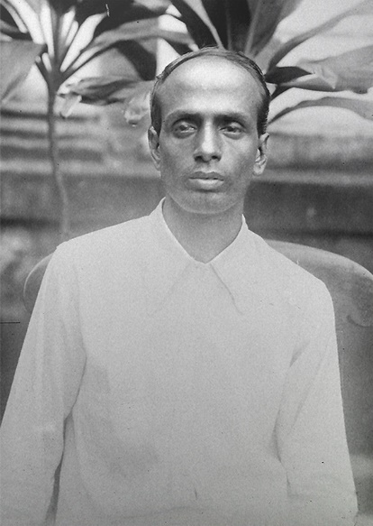"Surya Sen, a splendid and moving coordinator, was a simple, mild-mannered and straightforwardly earnest individual. Had tremendous and absolute boldness, he was profoundly conscious of others in his life. He was enamored with the saying: ‘Humanism is a special virtue of a revolutionary.’”, writes noted historian Bipin Chandra in his book India's Struggle for Independence 1857-1947. (Wangchuk, "Surya Sen, The Unsung Braveheart Whose Spirit Even Shattered Bones Failed To Break!", 2019)

Surya Sen was known widely by his supporters as the ‘Master Da’ which means School Teacher in English. He was the headmaster in the city of Noapara, Chittagong ( Now Bangladesh ). His movement for the Indian Freedom was established during his undergraduate studies at Berhampore College in 1916. He joined the Anushilan Samity, propelled by one of his instructors - established by Sarat Chandra Basu. Likewise, He workers with Chittaranjan Das - a political dissident who drove the Non-Cooperation Movement in Bengal and a solid promoter of peacekeeping. Sen was captured after the raid in Chittagong Armory for a long time back in 1926-28.

**Ganesh Ghosh**

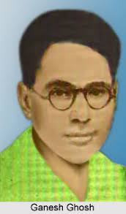Ganesh Ghosh was a Bengali Indian autonomy lobbyist, progressive and government official. Ganesh Ghosh hailed from Chittagong, presently in Bangladesh. In 1922, he took confirmation in the Bengal Technical Institute in Calcutta. Afterward, he turned into an individual from the Chittagong Jugantar party. He partook in the Chittagong ordnance strike, alongside Surya Sen and different progressives on 18 April 1930. He fled from Chittagong and took cover in Chandannagar, Hooghly. Following hardly any days police magistrate Charles Tegart assaulted the protected place of them in Chandannagar and captured him. One youthful individual progressive Jiban Ghoshal Alias Makhan killed by the police at the time of capture activity. After the preliminary, Ganesh Ghosh was expelled to the Cellular Jail in Port Blair in 1932. ("Ganesh Ghosh: The Asian Age Online, Bangladesh", 2019)

**Lokenath Bal**

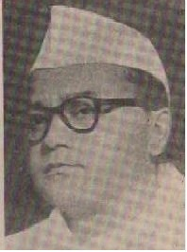Lokenath Bal was born on 8 March 1908 and died on 4 September 1964. He was also an Anushilan Samiti member and a leader of the Chittagong armory operation in 1930.

Lokenath Bal was brought up in the Chittagong of Bengal Presidency during the British Raj. After joining the Anushilan Samiti, he was picked by Surya Sen into the Chittagong Armory Raid group. Bal and Ganesh Ghosh were arrested on 1 September 1930 until 1946 after the attack. Bal became a member of the Indian National Congress, and he was a member of the administration of the Calcutta Corporation from 1952 to 1962. ("Lokenath Bal", n.d.)

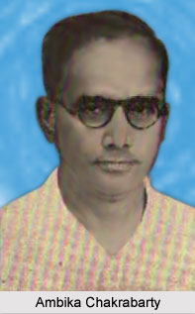**Ambika Chakrobarty**

Ambika Chakrabarty was a member of the Chittagong Jugantar party. He took part in the Chittagong armoury raid led by Surya Sen. On the night of 18 April 1930, when the attack was planned by Surya Sen. He got to lead the team and was incharge of destroying the entire communication system in Chittagong. After 4 days, when there was a gunfight in the hill tracks of Jalalabad, Ambika and along with his team was seriously injured. Immediately, they escaped from the scene but after a few days he was arrested by the British police. He got arrested and condemned to death later on. However, the sentence was later changed to transportation for life to the Cellular Jail in Port Blair. ("Ambika Chakrabarty", 2020)

**Harigopal Bal (Tegra)**

Harigopal Bal or Baulwas known as Tegra was a Bengali revolutionary who took part courageously in indian freedom movement against British ruling empire. He was also a part of the Chittagong Armory Raid. He died during the time of 22 April 1930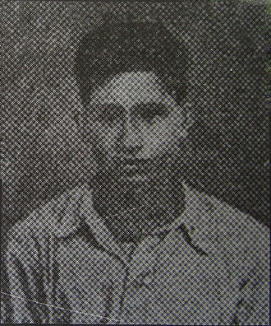.

Born in the village of Kanungopara in Chittagong, Bengal (now in Bangladesh). The name of his father was Pran Krishna Bal. Bal joined the group of Surya Sen and was a fighter in planning and execution of the Chittagong Armoury Raid.. He was the younger sibling of Lokenath Bal. Bal could escape after the somewhat successful mission.However, As he was injured after being shot while fighting against British troops on Jalalabad Hill after 3 - 4 days. (PeoplePill, "Harigopal Bal: Indian revolutionary (born: n/a - died: 1930)", n.d.)

**Ananta Singh**

Singh, Ananta was born during 1903 and died in the year of 1979. He lived his part of the life as an uprising raider, politician and one of the leading participants in the Chittagong Armoury Raid. Singh was born in Chittagong on 1 December 1903 while his father's name was Golap Singh.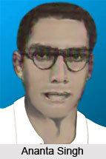

Singh’s journey on the Non-cooperation movement started during 1921. This was his first movement in the history of British Indian Rule. It was said that he motivated his schoolmates to join the movement. However, he was criticised for personally not having much faith in the movement. According to the plan made by Surya SenSingh and Nirmal Sen was incharge of the robbery that took place at the treasury office of the Assam Bengal Railway. After that night on 14 December 1923, they got into a clash with the then British police after the robbery and were arrested on 24 December 1930.

He was also recognised for the knowledge of making bombs and cartridges for the people and the revolts for defence against the britishers..

**Pritilata Waddedar**

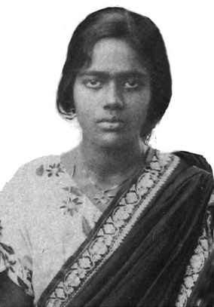Pritilata Waddedar was one the few revolutionary members of the Chittagong Armory Raid and played an influential part in the Indian independence movement, especially as a means for women empowerment. She was a student of Bethune College in Kolkata where she graduated from philosophy and later on became a school teacher.

Pritilata Waddedar was leading a group of fifteen revolutionaries during the armory attack planned by Surya Sen. She and her team carried out the plan of executing the Pahartali European Club where one of them was killed and eleven of them got injured. (Devakishen, et al., 2019) She did destroy the place but was later arrested by the police. As a part of the mission, she consumed cyanide and committed suicide to avoid being arrested.

**Kalpana Dutta**

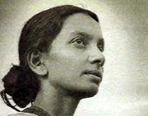Kalpana Dutta was another exceptional revolutionary born in that time. She was as influential as prithila during the Indian Independence Movement and joined the army led by Surya Sen. She was a member of the organisation Chhatri Sangha where she met Pritilata and through whom she later on got to know about Surya Sen. Therefore, she signed up to be part of the Chittagong raid.

Kalpana was incharge and responsible for the transport of the explosive and supplies from the attack where she was successful in knitting a cotton sack for the explosive to be a carrier. Through her research and scientific knowledge she was able to help the team to build a sustainable package for the transportation of the armories. She was also part of Pritilas planning on the raid. She was arrested by the British police before a week of the mission. We fled on bail and then helped with the plans of Prithila and Surya to torch the European Club. However, she was caught with others during the attack.

**Binod Bihari Chowdhury**

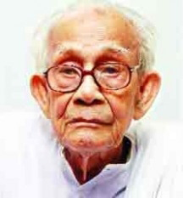Binod Bihari Chowdhury was another influential revolutionary among others who had a great impact on the Indian freedom movement and the Chittagong raid afterwards. He worked as a bangladeshi social worker and a veteran member of the civil society of Bangladesh.

During the year of 1927, Binod was a member of the anti-british group - Jugantar when he was suggested by a friend in school to join. Later he came to know Surya Sen and within a few days he became one of his trusted people in the group. After the plan was finally executed at 10 pm on 18 April 1930, Binod and his team mates were hidden in the Hills of Jalalabad taking shelter for the British police. Not for long she was hidden though. They were attacked immediately on 22 April where 80 Troops were killed of british police and 12 revolutionaries were dead. Rest of them were bought under trial and Binod was deported to the Detention camps in Rajputana. (Das, 2020)

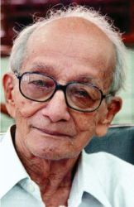**Subodh Roy**

Subodh Roy, born in 1916 within a rich family at Chittagong during the time of undivided and unruled Bengal. At the age of 14, he was the youngest participant of all in the Chittagong armory raid. Roy was one of the few first people that were sentenced after the raid. He was then discarded to Cellular Jail in Port Blair during 1934.

During 1940 when he was released from Jail, The Communist Party of India took him in as a member and he entered into communist politics. After 1947, He moved to Calcutta to join as a whole timer of the Provincial Centre of the Party. (Chattopadhyay, 2006)

**Monoranjan Bhattacharya**

Bhattacharya was born in Erikati, Faridpur District, British India. He participated in the progressive Madaripur gathering of Madaripur while a student. Bhattacharya took an interest in the Chittagong armory assault on 18 April 1930. (Chopra, P. N., 1969) His last activity was a mail sack burglary in Chamugaria on 14 March 1932. He acted upon a criminal offense by killing one post office worker when his act of robbery was caught red-handed.

Later on, After the almost successful raid, Bhattacharya and his four other colleagues were put in Faridpur Jail by the British police. He was declared to hang on 12 May 1932. And then executed In Barisal Regional Jail on 12 August 1932. Other co-accused were sentenced to various long terms of imprisonment. (Ghosh & Bhattacharya, 1998)

# Chittagong Armory Raid Plan

Surya Sen framed the idea and strategy of captivating the two main armories of the British in Chittagong. Afterward obliterating the telegraph and telephone office in the region to prevent troops from calling their central in Calcutta, to inform them about the attack. The plan also initiated with the butchery of members present in the "European Club '' situated in the port of Chittagong Armory.

Apparently, these were the people involved in conserving the British Empire in India for years and years. These included officials from the military and government personnel. Surya Sen also planned to rob the British funded banks and firearms retailers to be raided. While rail lines and communication lines were to be cut off in order to disconnect Chittagong from Kolkata and this would eventually buy them more time to carry out the operation.

# Execution of The Plan

The eighteenth of April 1930. At 10 PM, synchronous assaults started upon the Telegraph Office, the Armory and the Police Barracks. They altered the rail lines at Nangalkot and Dhum. Simultaneously, a pamphlet was communicated everywhere throughout the town, proclaiming that Gandhiji had offered the call to reprieve the law; thus, they would violate the law of conspiracy. They circulated another flyer clarifying the object of the attack marked by the “President of the Indian Republican Army, Chittagong Branch.” “This terrorist party had named itself the Chittagong Branch of the Indian Republican Army, with MASTERDA (SURJYA SEN) as its President.” (Dutt)

At the Armory, the rebels executed Major Ferrol, and two guards lost their lives at the Police Barracks. The Progressives took over The Armory and the Barracks. Likewise, they also tried to terminate The District Magistrate on showing up at the spot; however, they missed. He hurried to the wharf, and wirelessed abroad, and gathering all the accessible arms in the ordnance at the pier sent powers against the progressives. From the slope inverse the arsenal where there were waterworks, the Government counter-assault started. Be that as it may, regardless of their situation of weakness, the progressives had the option to toss back the Government powers.

In any case, it was risky to remain longer on that slope. Thus before the revolutionist left, they gathered all the arms they could. What they could not convey, they chose to wreck by pouring petroleum and burning down the entire arsenal.

The person who endured no misfortune in battling currently surpassed unintentionally. As the revolutionaries were spreading petroleum, Himangsu Sen burst into flames. Anantada, Ganeshda, along with two more took withering Himangsu to the city, where he kicked the bucket there sequestered from everything 3 days after the fact. The remainder of them went to the slopes to get ready for a - clearing assault upon the town. It was here that Anantada and the individuals who went down with him to the city left the remainder of the gathering.

The Battle of Jalalabad Hill! On the 22nd of April, at 4-30 PM at night, the progressives experienced the very much furnished, completely strengthened British soldiers. The progressives were on Jalalabad Hill and the British soldiers on the slope inverse. A customary pitched fight went on till sunset when the soldiers had to fall back. Many lost lives on the two sides. Among Chittagong’s progressive youth Jalalabad Hill turned into an adventure of unfaltering opposition. In the absolute first volley from the British automatic weapons, eleven progressives fell. Four were genuinely injured. Ambika Chakravarty, whose demise in the fight was reported by a Government dispatch, was injured, however, by and by got away with two other injured friends. The police just caught Ardhendu Dastidar injured and exposed him to brutal torments. He kicked the bucket a couple of days after the fact in police authority.

No positive figures of losses on the Government side were accessible. Gossip said 150 warriors got killed. The commander of the support that was brought from Agartala in Tipperary District admitted to a railroad representative that they had endured overwhelming misfortunes. A few months after the fact, when the authority took Ganesh Ghosh and others as prisoners, Sir Charles Tegart himself attacked them, and reviling them stated, “You have killed 64 of our men.”

The arrangement of assaulting the town must be surrendered after the unexpected Government assault at Jalalabad. Another choice was assumed the morrow of the fight: “Our work has not yet finished, the war with the Government still cannot seem to be pursued, and the fight for opportunity starting now and into the foreseeable future must be carried on by guerilla techniques. The individuals who can confront the terrible hardships of underground life as likewise the thousand-and-one risks of guerilla fighting, let just those stay. Others, who need to return can drop out of the line.” Moreover, a portion of the individuals who had not yet gone under police doubt was explicitly coordinated to get back in light of a legitimate concern for the development itself.

After two days, on the 24th of April, at Sadarghat around, seeing a youngster in an abandoned house, the police became dubious. The kid quickly hopped down from the next story and took cover under a road duct. Shots were traded until his pistol came up short on slugs then the soldiers originating from the opposite end destroyed him. “Amarendra Nandy was the name of the boy, and before taking to the hills after the Armoury Raid, Masterda had sent him to town to establish contact with Anantada and others. After finishing his assignment he was on his way back when he heard about the Jalalabad incident and so he took the road to the villages, but he turned back to town pledged to avenge the death of his comrades.” (Dutt)

Anantada’s gathering could not interface up with Masterda and the remainder of the organization. Catching wind of the Jalalabad fight, they left the town. Though they were apprehended in Feni Station, they managed to flee by killing a guard. This incident is praised as the Feni Incident.

Masterda drove the remainder of the gathering to the open country. They were on edge to continue ahead with their goal immediately—the Government was to be ceaselessly hassled by steady assaults.

On the sixth of May, a bunch comprising of Debiprosad Gupta, Manoranjan Sen, Rajat Sen, Swadesh Roy, Phanindra Nandi and Subodh Choudhury planned of assaulting the European quarters. Be that as it may, they could not go through with the arrangement. In transit, they faced a gathering of equipped police close Kalarpole, On this occasion, four were slaughtered, and Subodh and Phani were injured and captivated. Various goondas acquired to help the police were likewise executed or wounded.

Within some days, a portion of the young men was captured, while numerous others were captured from their own places. The entire of Chittagong was set under the military, and a time limit was implemented all over the place. Among those captured were the dads of Rajat (executed at Kalarpole), Debi and Ananta Singh. The police undermined them with genuine responses upon their children and the others. Hot endeavours were made to get the supporters of Crown against the progressives. Exactly right now, Ananta Singh gave up and, in this way, thwarted the Government endeavours at breaking the detainees’ spirit.

In 1930, the arraignment was propelled against 30 of the detainees, including Ananta Singh and different pioneers. Special tribunal got set so that the authority can attempt them, the principal charge being “taking up arms against the King-Emperor.” As the entirety of their exercises began with the strike on the ordnance, the preliminary came to be known as the “Chittagong Armory Raid Trial.”

On the first of September, 1930, law enforcers encompassed a home in late night at Chandranagore in Hooghly District, and Ganesh Ghosh, Ananda Gupta and Lokhnath Bai got caught and shipped to Chittagong. In the Chandranagore conflict, Jiban Ghoshal was murdered by police projectiles. With these captures, the Armory Raid Trial began once again.

After two months, Ambika Chakravarty was likewise captured in an extremely debilitating condition. The body of evidence against him was deferred, and he was confined in Sun Jail.

New captures were occurring ordinary, and the police mistreatment upon the individuals to get data about the progressives had gotten deplorable. The progressives by and by understood that they could not merely stay latent, while it was not right in simply the police catching them. Masterda set up joins with those in prison and started to make new plans.

On the 30th of December, Ramkrishna Biswas and Kalipada Chakravarty executed Inspector Tariiii Mukerji at Chandpur Station, confusing him with the Inspector General of Police, Mr. Craig. They were attempted in Calcutta, Ramkrishna Biswas was hanged, and Kalipada was shipped for life.

In June 1931 was found the explosive scheme in Chittagong. Arms, electric wires, explosives, blades, and so on were uncovered around the prison, also in court premises, and at other noticeable spots of the city, explosives were discovered covered beneath the ground.

People in general, as well as the authority, as well, were shocked by the disclosure of this far-reaching plot. Without a moment’s delay, the bail conceded to five of the denounced in the Armory Raid case was dropped, and two of them were absolved from their preliminary to be sent up regarding what came to be known as the Dynamite Conspiracy. A couple of more captures happened, and out and out eight got set on the Dynamite Conspiracy Trial, which also started before a special tribunal court. The authority attempted to go to a concilliation with Ananta along with his people, the tenure being that the denounced would all concede, and consequently, no one will be intensely condemned. The people were concerned that these would find some useful tasks to fulfill sentences. At the point, the judge’s decision got conveyed, and people discovered that three of them each got three years. Of the remaining, few got six, while others about eight months.

The general population was intrigued by the intensity of Ananta Singh and Ganesh Ghosh, with whom the Government itself had to settle.

Since the Armory Raid, police Inspector Asanullah had gotten particularly loathed for his unpredictable constraint. His character was additionally supposed to be spoiled. The individuals started to state: “The Swadeshis have accomplished such a great deal, wouldn’t they be able to show this miscreant a thing or two?”

In August 1931, on the football ground, fourteen-year-old Haripada Bhattacharya baffled Asanullah with slugs slaughtering him right there. Haripada was additionally gotten there, and being utterly sure that Haripada’s blame could be demonstrated, the Government allowed his preliminary by jury. Albeit prominent observer as such Rai Bahadur, Upen Roy Chaudhury got created, the proof resulted in no conflict with Haripada; the jury came to conclusion, ‘not guilty.’ The Government, in any case, took it to the High Court, and the decision switched, and Haripada got life transportation.

On the first of March, 1932, judgment was conveyed in the Armory Raid Case. Sixteen were genuinely cleared yet were detained under the Bengal Ordinance. Anantada along with twelve men got life transportation. Ananta Singh’s sibling Nandulal Singh got condemned to 3 years, Anilbandu Das 5 years. Ananta Singh, Rajat and Debi’s dads got discharged at the hour of the last charge-sheet.

Past to 1930, young ladies had joined the party. Since the Armory Raid, they started effectively to take an interest in progressive activity alongside men. Masterda had concluded that through this, he would show the people another and rousing element in progressive development.

In 1932, another conflict occurred between the police and the progressives at a haven in the town of Dhalgiiat. Here they lost Nirmal Sen and Apurva Sen and Capt. Cameron was slaughtered on the Government side. Masterda and Preeti Waddadar were additionally there; However, they got away. The woman by whom those rebels got roof, their child and other two were condemned to four years’ detainment each for sheltering the progressives.

After the Dhalghat occurrence, Preeti had to remain in isolation. Preeti had come to Dhalghat to meet Masterda only.

On the twenty-fourth of September, 1932, another assault occurred, this time upon Pahartali Railway Club and Preeti drove it. Thirteen were seriously injured by the official declaration, one Mrs. Sullivan was murdered. Preeti herself, in transit back, ended it all by taking potassium cyanide.

From her pocket was discovered an announcement composed by her and a handout which was given that day. “These stated that all that had happened since the Armoury Raid and was going to happen in the future was to be regarded as inci- dents in the war that the revolutionaries had declared against the British Government on the 18th April 1930, and so long as they were in bondage there could be no respite in this war.” (Dutt) Eighty-four were captured regarding the Pahartali attack; however, they were discharged for the need for proof.

Presently started the Armory Raid Supplementary Case with Ambika Chakravarty and two others. Following two months, Ambikada was condemned to death. From the two, one got lifetime transportation, and the other was imprisoned. Later on, the High Court drove Ambikada’s capital punishment to transportation forever.

At this point, Kalpana Dutt, as well, had remained in isolation and was moving with Masterda and the remainder of the gathering. Police watchfulness had seriously fixed, the military was positioned in each town, and each second there was the peril of experiencing them. In February 1933, Kalpana Dutt faced conflict with the police at the Gairala town; on their path to an arrangement, they fell into a police barricade. Following two hours of ordinary fight, Masterda and Brojen Sen, a neighbourhood kid, were caught. Brojen later was given four years. The remainder of the prevailing, got away; however, Santi Chakravarty and another confidant were genuinely injured.

On the nineteenth of May, while in an asylum at the town of Gahira, Anwara P. S., promptly in the first part of the day, they found that the police had encircled them. For quite a while, shots were traded. The proprietor of the house, Puma Talukdar, who had given them cover, was immediately slaughtered by police terminating. His more youthful sibling Nisi Talukdar was injured by a police slug going directly through his heart. What is more, with them - was murdered another youthful friend, 16-year old Manoranjan Das. Tarakeswar Dastidar and Kalpana Dutt were caught there. (Here as well, the woman of the house was given four years’ detainment.)

In June 1933, they started the Armory Raid Second Supplementary Case with Masterda, Tarakeswar Dastidar and Kalpana Dutt. Masterda and Tarakeswar were condemned to death, and Kalpana was given life transportation.

After this, individually, all started to be caught. Santi Chakravarty, Mani Dutta and Kalikinkar Dey, they had some way or another despite everything kept up the association—were all captured then.

The more youthful individuals at that point turned out to be practically frantic. They vindicated Masterda’s capture. On second of January, Netra Sen was butchered at Gairala, as he told the police about Masterda’s safe house. Around the same time, Himangsu Chakravarty, Nitya Sen, Haren Chakravarty and Krishna Chaudhury tossed bombs on the cricket ground and discharged shots. None of them was more seasoned than 16 or 17. Himangsu and Nitya kicked the bucket on the spot, Haren and Krishna were captured. After preliminary, they, as well, were executed.

After ten days, on the twelfth of January at 12 PM, the Government who controlled the whole town and the prison through army, killed Surjya Sen and Tarakeshwar Dastidar.

# Aftermath

Despair is a term unfamiliar to these heartless invincibles. The persecution of the Government certainly tried knocking the revolutionist. Still, they always got their people’s support and respect every second.

The Chittagong Party is undisputedly known as the strongest and most effective produced by the “terrorism” revolutionaries of Bengal. The Chittagong revolutionaries fought brave, albeit unjust, fights against the British authorities for almost 3 years, from April 1930 uuntil Surjya Sen’s capture in February 1933.

“Was there some common support behind them? Ganesh Ghosh’s emphatic response to this problem is that it would have been difficult for Surjya Sen and his courageous comrades to live underground in Chittagong itself for so long had there been no mainstream support. In reality, after the attack, the mindset of the Chittagong middle class transformed almost immediately into one of respect for the heroes and they offered them all sorts of help-refuge, money and legal protection. According to a hidden study, the revolutionaries enjoyed the support of the people, who generally warned them of the approach of the powers beforehand. Surjya Sen was a mythical figure, and his adherents worshiped him as a deity and a wide part of the populace looked upon him as a hero.” (Chatterjee)

The Chittagong attack has had a galvanizing impact throughout the province on revolutionaries. “Some of them couldn’t quite imagine the Bengali youth had attempted such a bold hack. But as the information got learned, the mindset of the Bengali revolutionaries shifted. The younger leaders of both parties who had already been shot with the intention of offering a definitive blow to the British asked for a chance to imitate the terrorists of Chittagong. The Chittagong heroes’ message entered even the farthest areas, stirring up women people and young girls “who are found to be supporting the terrorists as housekeepers, messengers, weapons custodians and often as comrades. “Within a month of the attack, the Jugantar in Calcutta under Bhupen Datta drawn up a proposal for significant actions of revolutionary terror. “The plans, according to a government document, were as follows: (a) murder of Europeans in hotels, clubs and cinemas, simultaneously in Calcutta and in the districts by bombs; (b) burning down of the Dum Dum aerodrome with petrol; (c) disruption of gas and electric supply of Calcutta,by blowing up the gas works and electric power stations; (d) cutting off the petrol supply of Calcutta by burning down the depot of the Burma Oil Company at Budge Budge; (e) disorganisation of tramway service in Calcutta by cutting wires; (f) destruction of telegraphic

communication between Calcutta arid the districts of Bengal; and (g) blowing up of bridges and railway lines by dynamites ana hand granades.” (Chatterjee)

It could only take up the first item of the above-mentioned programme. On 25 August 1930, the Jugantar hit the first blow. Anuja Sen and Dinesh Majumder targeted Tegart at Dalhousie Square with bombs. The bombs did not hit the object rather, a bomb that burst close to the “assailant” seriously wounded Anuja and he lost his life from hemorrhage. Two further bombings were carried out on 26 and 27 August in Calcutta.

The government acted immediately, arresting 18 people including Dr. Narayan today, Director, Company Calcutta. All was placed on the Dalhousie Square Bomb Case jury.

In April 1930 the Madaripur party, a Jugantar faction, committed a dacoity at Tala, Calcutta. On 25 August 1930, leaders of Dacca Sri Sangha fired in Lownan, I.G. Police and Hudson, S.P. Bullets entered Lowman’s leg, which died instantly. Hudson was fired in the right buttock, and his rectum was injured by the bullet.

One week on from the accident, the B.V. propelled. Benoy Bose, Badal Gupta and Dinesh Gupta infiltrated the Writers’ Buildings on 8 December 1930, fired at Col. Simpson, I.G. Jail, and wounded Sri Sangha’s Chaudhuri, killed Stevens, Comilla’s District Magistrate. After that, succeded the assassination of 3 consecutive magistrates in Midnapore — Peddie in 1931, Douglas in 1932 and Burge in 1933 — and eventually, a strafe to eliminate Anderson’s head, Governor of Bengal, right on the Darjeeling Lehong Race on May 1934.

The raid on Chittagong had also inspired the Anushilan’s young militants, who demanded immediate action. But the government’s swift intervention against the perpetrators, which contributed to the 1933 Inter-Provincial Assassination Trial, delivered a difficult blow from which it did not completely recover.

In many ways, the Chittagong rebellion represented not just the height of democratic movement in Bengal but also a starting point. It wasn’t actually the elimination of human rivals; rather, it was idealistic devastation among one tiny section of British control on India. This was the key focus of the Chittagong rebellion, although for a limited period. This is evident from the Indian Republican Army Declaration. Second, after Jalalabad’s valiant combat, Surjya Sen intended to withdraw from Chittagong to the villages to organise guerrilla sorties against the British government. This showed a radical consciousness on a new and higher stage. Some of Surjya Sen’s closest comrades emphasized that by 1931 he tended towards widespread political action, as his appreciative relation to the radical Burmese Saya Sen. Both of these appear to participate in the Chittagong rebellion with a degree of significance unmatched in the annals of the Indian independence struggle.

“The successful armoury7- raid failed because it was not followed up by any armed struggle of the masses. Despite this basic limitation, the raid succeeded in vindicating the great revolutionary principle: a people determined to wage an armed straggle against their oppressors do not lack arms.” (Chatterjee)

# Impacts of the Uprising:

1. Chittagong armory raid shook the foundation of British rule in India. It inspired lots of young men and women to raised their voice against colonial rule.
2. After the Chittagong armory raid, many Indian people started to become more concerned about their political freedom and rights.
3. Chittagong Armory raid created nationalism among Indian people and accelerated the movements of Indian Independence.

# Conclusion

In this event, the heroes sacrificed their lives against the British in the mere hope of hurting them. At that time, the British exercised their power through the weapon or gun, ammunition, and the rebels' plan was to remove the place where that ammunition was kept, but they failed. Pritilata Waddedar was one of the few revolutionary members of the Chittagong Armory Raid. She played a dominant rule in the Indian independence movement. She enlightened many women throughout the world, and is often called the “Firewoman.” The impact of this Chittagong armory raid shook the foundation of British rule in India; also, it woke up many youngers against colonial rule. In the end, we discuss some lines of a letter written by Surya Sen, “Never forget the 18th of April,1930, the day of the eastern Rebellion in Chittagong... Write in red letters in the core of your hearts the names of the patriots who have sacrificed their lives at the altar of India's freedom.” So, we can conclude that the Chittagong rebellion represented the starting point and also the height of a revolutionary movement in the whole of India.

# Works Cited

Baber, Z. (1996). *The science of empire: Scientific knowledge, civlization, technology and*

*society.* Albany, NY: State University of New York Press.

Chaudhary, L. (2009). Determinants of primary schooling in British India. *The Journal of*

*Economic History*, 69(1), 269.

Loomba, A. (1998). *Colonialism/Postcolonialism.* London, England: Routledge.

Lyer, L. (2010). Direct versus indirect colonial rule in India: long-term consequences. The Review of *Economics and Statistics,* 92(4), 693–713.

Lloyd, D. (2008). Ireland after history. In H. Schwarz & S. Ray (Eds.), *A Companion to Postcolonial Studies* (pp. 377–395). Oxford, England: John Wiley & Sons.

Stokes, E. (1973). The First Century of British Colonial Rule in India: Social Revolution or Social Stagnation? *Past & Present*, 58, 136–160.

Wikipedia contributors. (2020, April 4). Chittagong armoury raid. In Wikipedia, The Free Encyclopedia. Retrieved 15:22, May 28, 2020, from <https://en.wikipedia.org/w/index.php?title=Chittagong_armoury_raid&oldid=949014940>

Wikipedia contributors. (2019, May 9). Ambika Chakrabarty. In Wikipedia, The Free Encyclopedia. Retrieved 16:02, May 28, 2020, from <https://en.wikipedia.org/w/index.php?title=Ambika_Chakrabarty&oldid=896319185>

Wikipedia contributors. (2020, May 11). Pritilata Waddedar. In Wikipedia, The Free Encyclopedia. Retrieved 16:20, May 28, 2020, from <https://en.wikipedia.org/w/index.php?title=Pritilata_Waddedar&oldid=956093280>

Wikipedia contributors. (2020, May 20). Binod Bihari Chowdhury. In Wikipedia, The Free Encyclopedia. Retrieved 16:30, May 28, 2020, from <https://en.wikipedia.org/w/index.php?title=Binod_Bihari_Chowdhury&oldid=957884810>

Chopra, P. N., Chavan, Y. B., & India. (1969). Who's who of Indian martyrs. New Delhi: Ministry of Education and Youth Services, Govt. of India.

Chattopadhyay, S. (2006, September 21). Model revolutionary. Retrieved from https://frontline.thehindu.com/other/obituary/article30210972.ece

Das, U. S. (2020, April 10). Binod Bihari Chowdhury: Tribute to a revolutionary and a true patriot. Retrieved from https://tbsnews.net/panorama/binod-bihari-chowdhury-tribute-revolutionary-and-true-patriot-67438

Devakishen, B. A., Devakishen, B. A. D. B., Devakishen, B. A., Devakishen, B., University of East Anglia, & University of East Anglia. (2019, March 14). The Women Warriors of the Chittagong Armoury Raid: #IndianWomenInHistory. Retrieved from <https://feminisminindia.com/2019/03/15/women-warriors-chittagong-armoury-raid/>

Ganesh Ghosh: The Asian Age Online, Bangladesh. (2019, October 15). Retrieved from https://dailyasianage.com/news/200730/ganesh-ghosh

Ghosh, K. C., & Bhattacharya, S. (1998). *Chronological dictionary of Indias independence*. Calcutta: Sahitya Samsad.

Lokenath Bal. (n.d.). Retrieved from https://historica.fandom.com/wiki/Lokenath_Bal

PeoplePill. (n.d.). Harigopal Bal: Indian revolutionary (born: n/a - died: 1930). Retrieved from https://peoplepill.com/people/harigopal-bal/

The Chittagong uprising. (2010, December 2). Retrieved from https://www.hindustantimes.com/bollywood/the-chittagong-uprising/story-Oi3AqwFItKWb2edBGFFwIN.html

Wangchuk, R. N. (2019, August 8). Surya Sen, The Unsung Braveheart Whose Spirit Even Shattered Bones Failed To Break! Retrieved May 28, 2020, from https://www.thebetterindia.com/135249/surya-sen-revolutionary-freedom-struggle-chittagong/

Chatterjee, M. (n.d.). *Do and Die: The Chittagong Uprising 1930-34.* Retrieved from http://shodhganga.inflibnet.ac.in/jspui/bitstream/10603/205248/9/09_chapter%206.pdf

Dutt, K. (n.d.). *Chittagong-Armoury-Raiders-Reminiscences.* Retrieved from Archive.org: https://archive.org/stream/in.ernet.dli.2015.59007/2015.59007.Chittagong-Armoury-Raiders-Reminiscences_djvu.txt